St. John’s United Church of Christ
201 West Market Street Germantown, OH 45327
December 31, 2023, 10:30AM
First Sunday after Christmas
Liturgist: Brenda Williams Organist: Decker Jones Pastor: Mark Anthony

Announcements
Lighting of the Candles
Welcome
Passing of the Peace

Prelude Nations Shall Come Louis-Claude Daquin

*Call to Worship
One: In the darkness, look to the light that cannot be overcome.
Many: We turn to you, Jesus, Light of the World.
One: In the chaos of this world, set course by the unwavering star.
Many: We follow you, Jesus, our Constant Guide.
One: In the painful disunity of our lives, embrace the unity of God’s love.
Many: We abide in you, Jesus, Healer of our souls. Amen.

*Hymn We Three Kings Red No. 172
Verses 1-5

*Opening Prayer
Leader: Let us pray.
People: God beyond our knowing, the boundaries we draw around
ourselves have no authority over you. Your love extends to all
nations and races, all genders, and religions. You call us to unity, not
division. Change our hearts, God of Mercy, to be more like you. Draw
us to the light of your grace, that we may be a source of healing in
our world. We pray in Jesus’ name. Amen.

Musical Offering Video

Children’s Moment

Scripture Isaiah 60: 1-6 &
Matthew 2: 1-12

Message “Light For The Nations”

*Hymn As Grain on Scattered Hillsides Brown No. 491
Verses 1 & 4

*The Offering

*Doxology
All: Praise God from whom all blessings flow, Praise Him, all creatures here below, Praise Him above, ye heavenly hosts, Praise Father, Son, and Holy Ghost. Amen.

Pastoral Prayer and the Lord’s Prayer

*Closing Hymn We’ve a Story to Tell the Nations Brown No. 296
Verses 1 & 3
*Dismissal with Blessing

Postlude By No Means Least Dorothy Wells

*All join us in standing as able
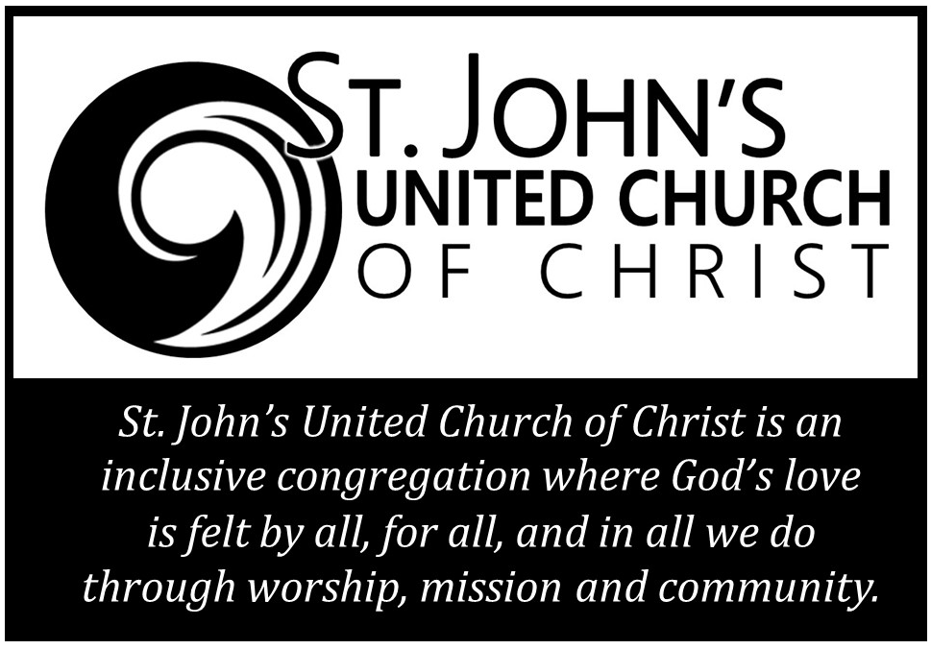
Calendar of Events
Sunday (12/31): | 10:30AM  12:00PM | Worship  Bell Choir Practice | Sanctuary
Thursday (01/04): | 12 – 2PM  7:00PM | Food Pantry  Chancel Choir Practice | Brombaugh Rm

Staff:
Pastor: Rev. Mark Anthony (937) 657-5347
Pastormanthony45327@gmail.com

Emeritus: Rev. Mark L. Williams (937) 696-7412

Organist/
Music Director: Decker Jones deckerjones@sbcglobal.net

Treasurer: Pat Schaeff

Financial Secretary: Barbara Craycraft Office Hours 9AM-2PM M-F
SecretaryStJohns937@gmail.com
Worship Team:
Liturgist: Brenda Williams
Greeter: TBA
Godly Play Leader: Erin
Godly Play Lesson: Christmas – Meeting the Christ Child (p.143)
Tech: Kendall Peters, Rich Miletic, Nancy McDonnell, DJ Truax,
Grace Gregor, Tom Weaver

December 31, 2023

201 West Market St.
Germantown, OH 45327
937-855-2050

